**Online Blood Donation and Management System**

**SYNOPSIS**

**Submitted by**

**Gopal Tiwari (150018770)**

**Ayush Goyal (1500180057)**

**Naveen Gupta (150018322)**

**Vineet agrawal (150018477)**

**Ramballabh Agrawal (150018842)**

***In partial fulfilment of the***

***Requirements***

***For the degree of***

***Bachelor of technology***

***In***

***Computer science***



**Supervised By**

**Dr. Manoj Varshney**

**Department of Training and Development**

**GLA University Mathura**

**Problem Statement**

Despite advances in technology, today's blood bank systems are running in manual system.

As such, there is a prevalent problem in the availability of needed blood types. For instance,

when a person needs a certain type of blood and this type is not available in the hospital, family

members send messages through social media to those who can donate to them and this process

takes longer than the life of the patient to the most dangerous. In addition, it seems that there is

lack of proper documentation about blood donors and its medical history. This may lead to blood

bag contamination and may affect the blood transfusion safety.

Generally, this study aims to determine how the use of online b

Despite advances in technology, today's blood bank systems are running in manual system.

As such, there is a prevalent problem in the availability of needed blood types. For instance,

when a person needs a certain type of blood and this type is not available in the hospital, family

members send messages through social media to those who can donate to them and this process

takes longer than the life of the patient to the most dangerous. In addition, it seems that there is

lack of proper documentation about blood donors and its medical history. This may lead to blood

bag contamination and may affect the blood transfusion safety.

Generally, this study aims to determine how the use of online b

Despite advances in technology, today's blood bank systems are running in manual system.

As such, there is a prevalent problem in the availability of needed blood types. For instance,

when a person needs a certain type of blood and this type is not available in the hospital, family

members send messages through social media to those who can donate to them and this process

takes longer than the life of the patient to the most dangerous. In addition, it seems that there is

lack of proper documentation about blood donors and its medical history. This may lead to blood

bag contamination and may affect the blood transfusion safety.

Generally, this study aims to determine how the use of online b

Despite advances in technology, today's blood bank systems are running in manual system.

As such, there is a prevalent problem in the availability of needed blood types. For instance,

when a person needs a certain type of blood and this type is not available in the hospital, family

members send messages through social media to those who can donate to them and this process

takes longer than the life of the patient to the most dangerous. In addition, it seems that there is

lack of proper documentation about blood donors and its medical history. This may lead to blood

bag contamination and may affect the blood tr

Despite advances in technology, today's blood bank systems are running in manual system. As such, there is a prevalent problem in the availability of needed blood types. For instance, when a person needs a certain type of blood and this type is not available in the hospital, family members send messages through social media to those who can donate to them and this process takes longer than the life of the patient to the most dangerous. In addition, it seems that there is lack of proper documentation about blood donors and its medical history. This may lead to blood bag contamination and may affect the blood transfusion safety.

So Our aim is to build a Web Based Blood Donation and Management System, Which will manage the information of every hospital and blood stock in every hospital, have the verified information about the Donors and the Patients.

**Reason for selecting this topic**

Blood transfusion safety remains an important public health concern in India. The availability of blood products of all blood types and the provision of its safety ensure public trust of its excellent healthcare system. However, lack of availability of these blood products and provision of unsafe blood products still impact morbidity and mortality in the Sultanate. Through the use of online blood donation and management system, blood transfusion safety is expected to be enhanced or improved. Risks on improper blood donors’ documentation and misplaced records can be minimized or totally avoided. Also, processes involving blood bag collection, storage, and inventory will be systematized and organized, hence, improving the healthcare management.

**Objective**

This Project aims to design, develop and implement online blood donation and managementsystem. This web-based application provides:

* To ensure hospital to have good supply or inventories of blood bags.
* To check the availability of blood bags anytime.
* To manage the information of its blood donors.
* To manage the information of the patients.
* To allow good documentation about the donor and its blood donation activities.
* Support fast searching to find match blood bags for the right person.

**Literature Survey**

There are quite good number of software packages that exist for BLOOD BANK Inventory control. But these existing systems is limited only in some blood bank. At the present there is no software to keep any records in thousands of blood bank. It becomes difficult to provide any record immediately at times of emergency. Required more human efforts in maintaining the branch related information.

Manually to keep the accounts is also tedious & risky job. To maintain those accounts in ledgers for a long period is also very difficult if the data is stored in the files for long duration of time. Privacy is very difficult. Retrieving, storing and updating the data is time consuming. It is difficult to keep track the record about the donor &receiver blood transactions.

There are several Studies in this field such as:

The study entitled “Blood Bank Management System” done by Kumar,R., Singh, S. and Ragavi, V.A. (2017), the researchers developed a web-based blood management which assists the blood donor records management, and provides ease of control inthe distribution of blood products in various parts of the country considering demands ofhospitals. The developed system was scalable and adaptable to meet the complex needs usuallyof a blood bank. Based on this study, since entering the details about the blood donors andrelated records were done manually, thus, tracking of blood donation activities was difficult andcomplicated, and even led to erroneous information. Subsequently, the researchers mentionedthat manual-based system can be waste of time, lead to the error-prone results, consumes a lot ofmanpower, lacks data security, data retrieval requires a lot of time, reports consumes a long timeto produce, and there is less precise accuracy on the results. As such, by developing andimplementing a web-based blood management information system, there was a quick and timelyaccess to donor records, and the system provided management timely, confidential and securedmedical reports. There were three (3) users in the system, namely: Administrator, Donor, andAcceptor. Each user has been given user ID and password to identify their identity.

In the study entitled “Blood Bank Management System Using Rule-Based Method”undertaken by Liyana, F. (2017), it found out that it is important for every hospital to use aninformation system to manage data in blood bank. Also, it observed that the manual system hasdisadvantages for the user and the hospital. One of the disadvantages identified was the bloodbank staff should enter the donor details in each time he/she donate blood in which led toduplicate data of the donor and also the data may be lost or missing after period of time. Thus,the author developed a web-based system to help the blood bank to record the donor details fastand easy. The system used rule-based decisions to ensure to have a right decision on right time.Also, system can send messages to donors if any particular blood type is needed. She developedblood bank system based on incremental model. She had chosen this model because the system can be developed through cycle of phase and also because of the advantages of this model suchas:

* Easy to understand to flow of the phases.
* Changes possible in the middle of any phases.
* The system can be developed even if there is an error in the middle and it can becorrected in testing phase.In this study, the researchers observed that the developer failed to include in the system thefunction to check the availability of blood bags, and to check the shelf life or expiration of bloodbags or products. As such, the researchers will include these in their developed system toenhance safety for blood transfusion.

**Future Scope**

* This System can be expanded with availability over worldwide.
* A smart phone application of the system can be made.
* Connecting large number of users with the system.
* Blood disease detection system can be integrated with this system to provide user more information.

**Methodology**

**Description**

The waterfall Model is a linear sequential flow. In which progress is seen as flowing steadily downwards (like a waterfall) through the phases of software implementation. This means that any phase in the development process begins only if the previous phase is complete. The waterfall approach does not define the process to go back to the previous phase to handle changes in requirement. The waterfall approach is the earliest approach that was used for software development.

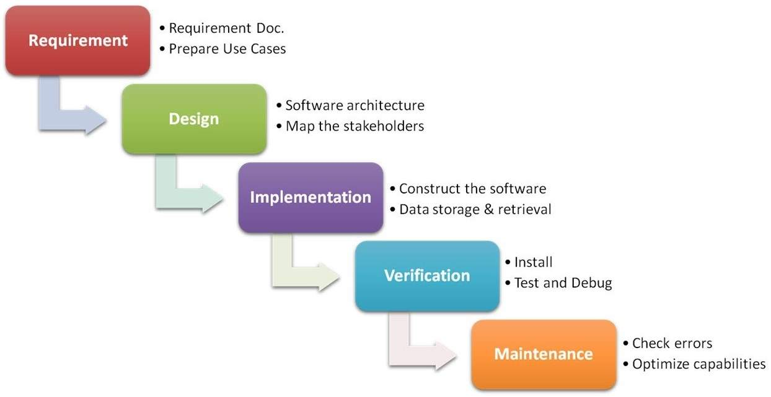

This Project will contain the complete details of the blood bank that which blood group has the which amount of blood we have and according to it provide the blood to the needy persons and reduce their problems to save their time.

**Hardware and Software Required**

* **Software Requirements:**
* Operating System: Windows 7 or higher
* IDE: Visual Studio Code
* Front-End: HTML, CSS, JavaScript, React
* Back-End: NodeJS
* Database: MongoDB
* **Hardware Components:**
* Processor – Core i3
* Hard Disk – 160 GB
* Memory – 2 GB RAM
* Intel P4 1.5GHz or above

**What contribution would the project make and where**

* The specification builds on the experience of users of IT technology in blood transfusion that is currently available and informs both connecting for Health and commercial companies producing both hardware and software.
* The main contribution of this specification is to support the automated tracking of blood products from the ordering of blood transfusion for a patient, through to the tasking of a blood sample for cross matching.
* Routine blood transfusion.
* Emergency issue of blood.
* Management of returned and unused blood units.

**Scope for extension into a major project**

We can provide our users more facilities at a single place for example we can expand our project with the help of various technologies such as Machine Learning, Artificial Intelligence. For example we can implement a disease detection system with in this project where patients can enter the problems they are facing or reasons why they need flood for. And then our system can predict their disease and recommend them the best possible solution.

**Conclusion**

The aim of our project is to create a bridge between the demand and supply of blood. The main purpose of this project is to bring the donor and the patient in a common platform. The most important view point is that the men and women who are willing to donate blood to the patients.

It should encourage new donors and retain old donors to donate blood. This Project is to overcome the problems of the existing system. For every blood demand request it will improve the efficiency of data communication within the supply chain.